Aaron Hill – group 13– sprint 1 – user stories, scenarios and features

1. Scenario – Gabe
   1. Gabe is an adult student that has decided to get a degree in computer science in his 30’s. He often feels overwhelmed by the difficulty of some of his classes and in his internship. He needs another resource that is catered to his specific course load and work interests and puts them all in one place. He hears about 49extend, which is a service that can help him academically, socially and professionally. He uses the platform to catch up in his computer architecture course and to find out more about databases and SQL, which is pertinent to his internship in the summer.
2. User Story

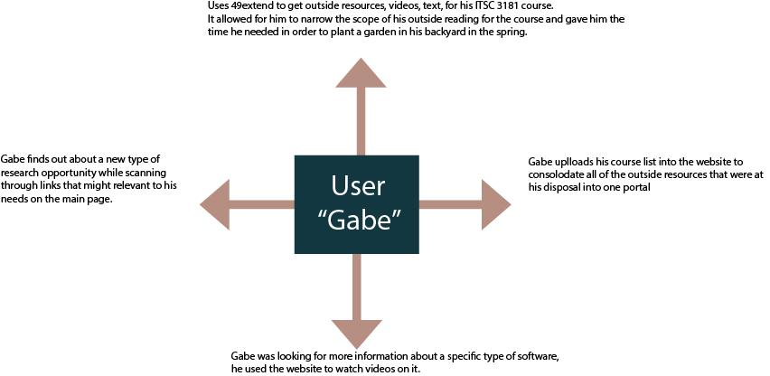

1. Features
   1. Ability to consolidate outside resources for academic purposes
      1. As well as looking for internships/jobs
   2. Upload current course load to analyze what resources are available for the student
   3. Simplify learning process for more difficult topics
      1. Break it down into smaller modules